CPSC131

MATRIX HW Name _________________________

**Problem 1** (4 pts)Given the following matrices, compute**:**



**(a)** *D* + *B* **(b)** *A* + *ET* **(c)** *B* – 2*D*

**(d)** 7*B* **(e)** *DB* **(f)** *BA*

**(g)** *AC* **(h)** *2DA*

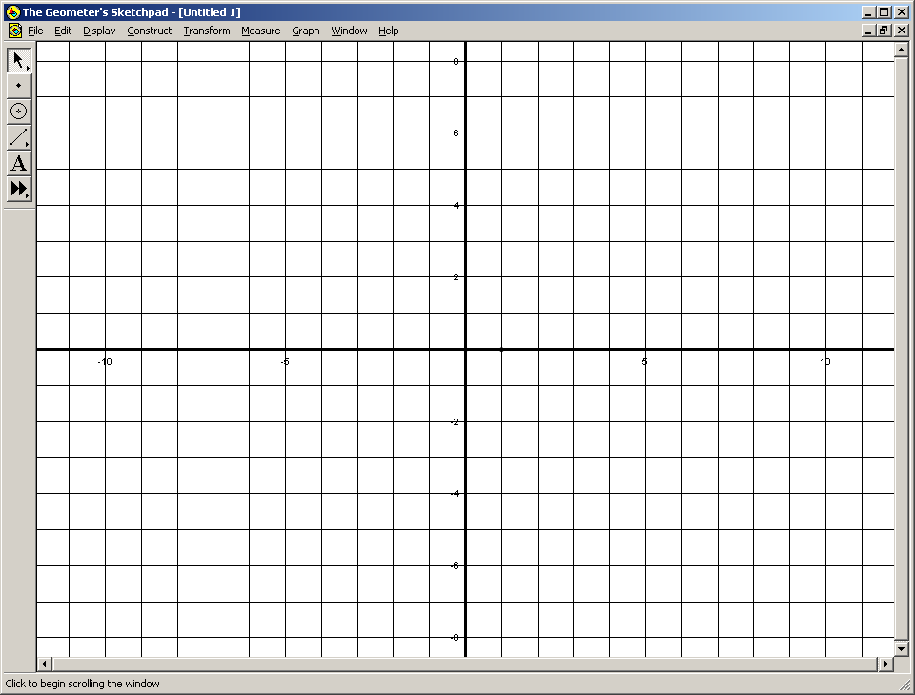

**Problem 2** (8 pts) Given the system of equations: *x1* – 2*x2* = 1

2 *x1* - *x2* = 5

**a)** Plot the system and estimate the solution.

**b)** Solve using Gauss elimination. Show all steps of the computation. Check your results by substituting them back into the equations.

**c)** Solve the system using EXCEL.

**Problem 3** (8 pts) Given the set of equations: 2*x1* + 4*x2* – 10*x3* = -2

3*x1* + 9*x2* - 21*x3* = 0

*x1* + 5*x2* - 12*x3* = 1

a) Solve by Gauss elimination. Show all steps of your computations.

b) Substitute your results into the original equations to check your answers.

c)Solve the system using EXCEL.